**ONE PAGE WRITE-UP FOR THE PROJECT**

NAME: JEEVANANTHAM V

REG. No.: 2021506031

**Project title**: HOTEL REVENUE MANAGEMENT SYSTEM

**PROBLEM STATEMENT:**

Hotel revenue management system is one of the most important processes. Many hotels fail to manage the revenue of the hotel day to day. There are certain strategic databased decisions. It helps to forecast the demand, optimize prices and room availability, and boost hotel revenue. Since the hotel are calculating the revenue manually more revenue leakage could happen. So that some of the KPI’s (Key Performance Indicators) are checked to minimize the leakage.

In order to solve these problems, automation is needed.

**ARCHITECTURAL DIAGRAM:**

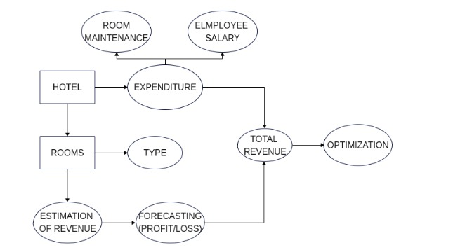

**OUTCOMES AND DELIVERABLES:**

* Average daily rate of the rooms will be calculated.
* Total room revenue will be calculated.
* Gross operating profit per available room calculation will be easier.
* Revenue leakage issues can be minimized
* It helps keep tracking of the hotel revenue and profits.
* Hotels financial performance can be managed easily.